

WT ASSIGNMENT-3

• Name :HITU RAJ

• Roll no. :2005025

• Branch :CSE

// 1. Design an applet to display the user information such as Roll No., Name,

// Branch and Section in separate lines.

import java.applet.*;

import java.awt.*;

public class q1_student extends Applet

{

    public void paint (Graphics g)

    {

        String name = getParameter("name");

        String rollno = getParameter("rollno");

        String branch = getParameter("branch");

        String section = getParameter("section");

        g.setColor(Color.GREEN);

        Font f=new Font("TIMES ROMAN", Font.BOLD | Font.ITALIC,34);

        g.setFont(f);

        g.drawString("Name : "+name,70,50);

        g.drawString("Roll no : "+rollno,70,100);

        g.drawString("Branch : "+branch,70,150);

        g.drawString("section: "+section,70,200);

    }

}

/*<applet code="q1_student" height=500 width=500>

<param name="name" value="HITU RAJ"> </param>

<param name="rollno" value="2005025"> </param>

<param name="branch" value="CSE"> </param>

<param name="section" value=" 12"> </param>

</applet>*/

OUTPUT-1

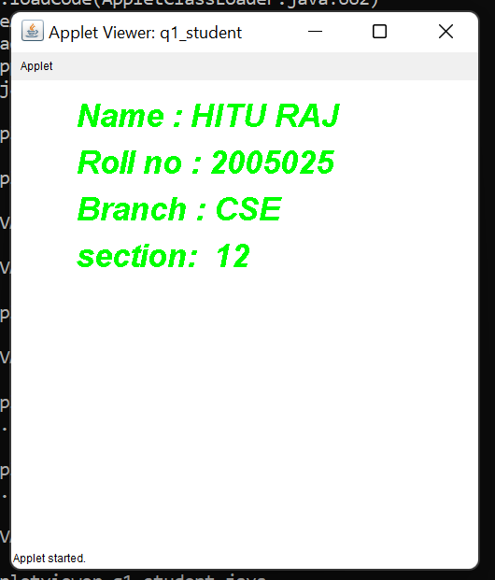

// 2. Design an applet to display a colored smiley.

import java.applet.*;

import java.awt.*;

public class q2_smiley extends Applet

{

    public void paint(Graphics g)

    {

        g.drawString("HITU RAJ_2005025 ",70,50);

             g.setColor(Color.orange);

        // Oval for face outline

        g.fillOval(100, 100, 400, 400);

        // Ovals for eyes

        g.setColor(Color.BLACK);

        g.fillOval(200, 250, 50, 50);

        g.fillOval(350, 250, 50, 50);

        // Arc for the smile

        g.drawArc(200, 350, 190, 90, 180, 180);

    }

}

/*<applet code ="q2_smiley" width=600 height=600>

</applet>*/

OUTPUT-2

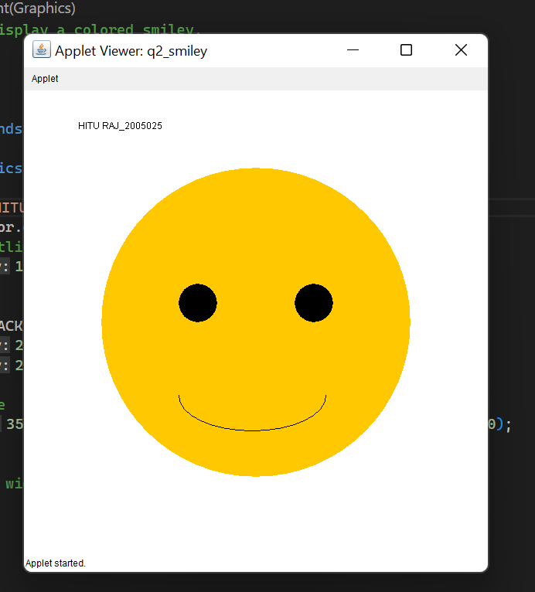

// 3. Design an applet with following components on it – Label, Textbox, Text area,

// Checkbox, Radio button and Button.

import java.applet.*;

import java.awt.*;

public class q3_checkboxes extends Applet

{

    Label label = new Label ("Welcome TO HITU RAJ CODE");

    Button button = new Button ("Button");

    Checkbox toggle = new Checkbox ("Toggle this");

    TextField text = new TextField ("Sample textarea", 200);

    public void init ()

    {

    add (label);

    add (button);

    add (toggle);

    add (text);

    }

}

/*<applet code ="q3_checkboxes" width=300 height=600>

</applet>*/

OUTPUT-3

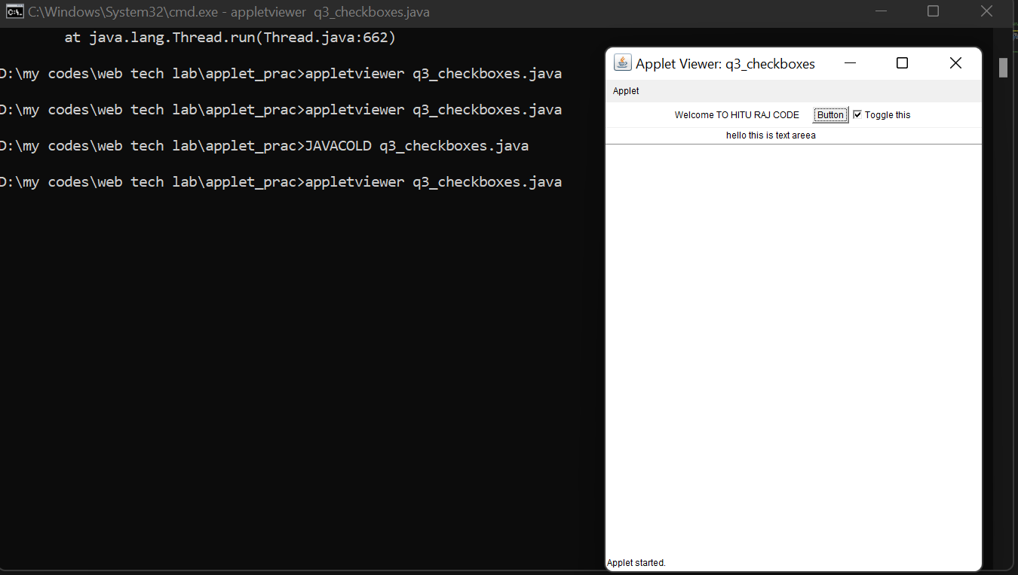

// 4. Write a program in Java to copy the content of a given file to another user

// entered file using character stream.

import java.io.*;

import java.util.*;

public class q4_Filecopy

{

    public static void copyData(File file1, File file2) throws Exception

    {

        FileInputStream ip = new FileInputStream(file1);

        FileOutputStream out = new FileOutputStream(file2);

        try

        {

            int i;

            while ((i = ip.read()) != -1)

            {

                out.write(i);

            }

        }

        catch(Exception e)

        {

            System.out.println("Error Found: "+e.getMessage());

        }

        finally

        {

            if (ip != null)

            {

                ip.close();

            }

            if (out != null) {

                out.close();

            }

        }

        System.out.println("File Copied");

    }

    // main() method start

    public static void main(String[] args) throws Exception

    {

        Scanner sc = new Scanner(System.in);

        System.out.println("Enter the name of the file from where the data would be copied :");

        String file1 = sc.nextLine();

        // create instance of the File class for the source file

        File a = new File("C:\\Users\\KIIT\\Desktop\\"+file1);

        // get the file in which the data would be written.

        System.out.println("Enter the name of the file from where the data would be written :");

        String file2 = sc.nextLine();

        // create instance of the File class for the destination file

        File b = new File("C:\\Users\\KIIT\\Desktop\\"+file2);

        sc.close();

        // method called to copy the data from file a to file b

        copyData(a, b);

    }

}

OUTPUT-4

File1.txt

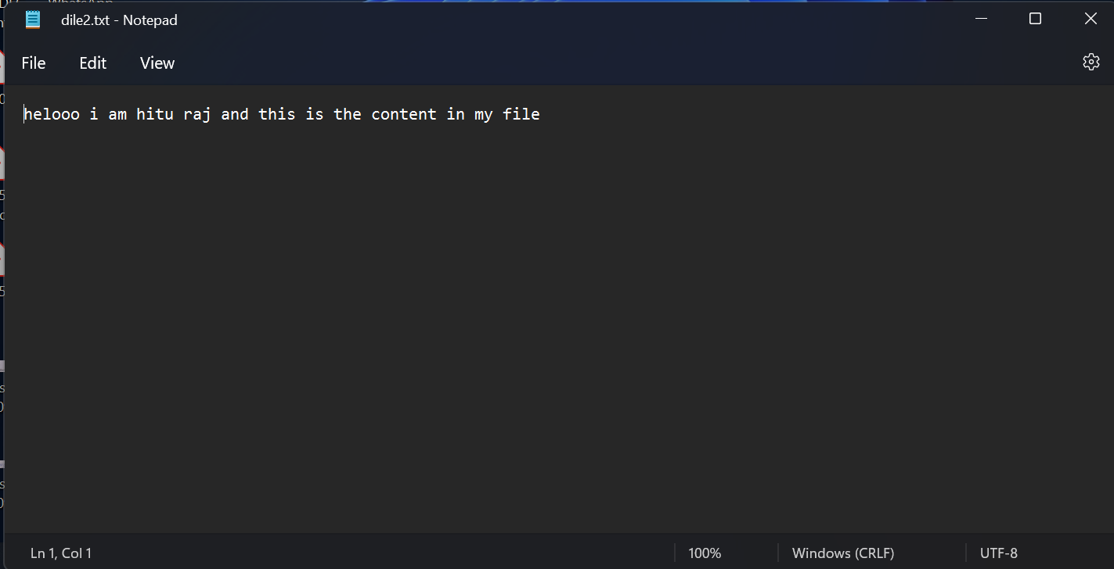

Dile2.txt(copied file)

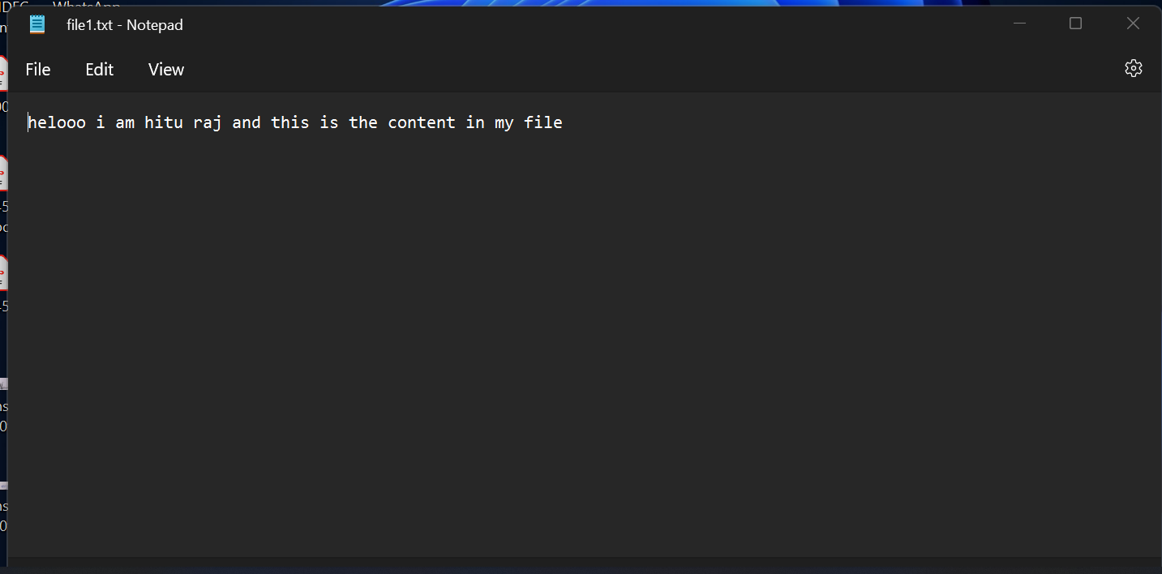

// 5. Design an applet with one label, one text field and one button so that on

// clicking the button it will check and display in the applet whether the value entered

// in the text field is even or odd or blank.

import java.awt.*;

import java.applet.*;

import java.awt.event.*;

public class q5_oddeven extends Applet implements ActionListener

{

            TextField input;

            Button check;

            int flag=0;

            public void init()

            {

                        check=new Button("check");

                        Label inp=new Label("Enter any number :",Label.RIGHT);

                        input=new TextField(5);

                        input.setBackground(Color.yellow);

                        add(inp);

                        add(input);

                        add(check);

                        input.addActionListener(this);

                        check.addActionListener(this);

            }

            public void actionPerformed(ActionEvent ae)

            {

                        String str=ae.getActionCommand();

                        if(str.equals("check"))

                        {

                                    int n=Integer.parseInt(input.getText());

                 flag=0;

                                    if(n%2==0)

                                    {

                                        flag=1;

                                    }

                        }

                        repaint();

            }

            public void paint (Graphics g)

            {

                if(flag == 1)

                    g.drawString("Even number",100,200);

                else if(flag==0)

                    g.drawString("odd number",100,200);

            }

}

/*<applet code="q5_oddeven" width=500 height=500></applet>*/

OUTPUT-5

For even no.

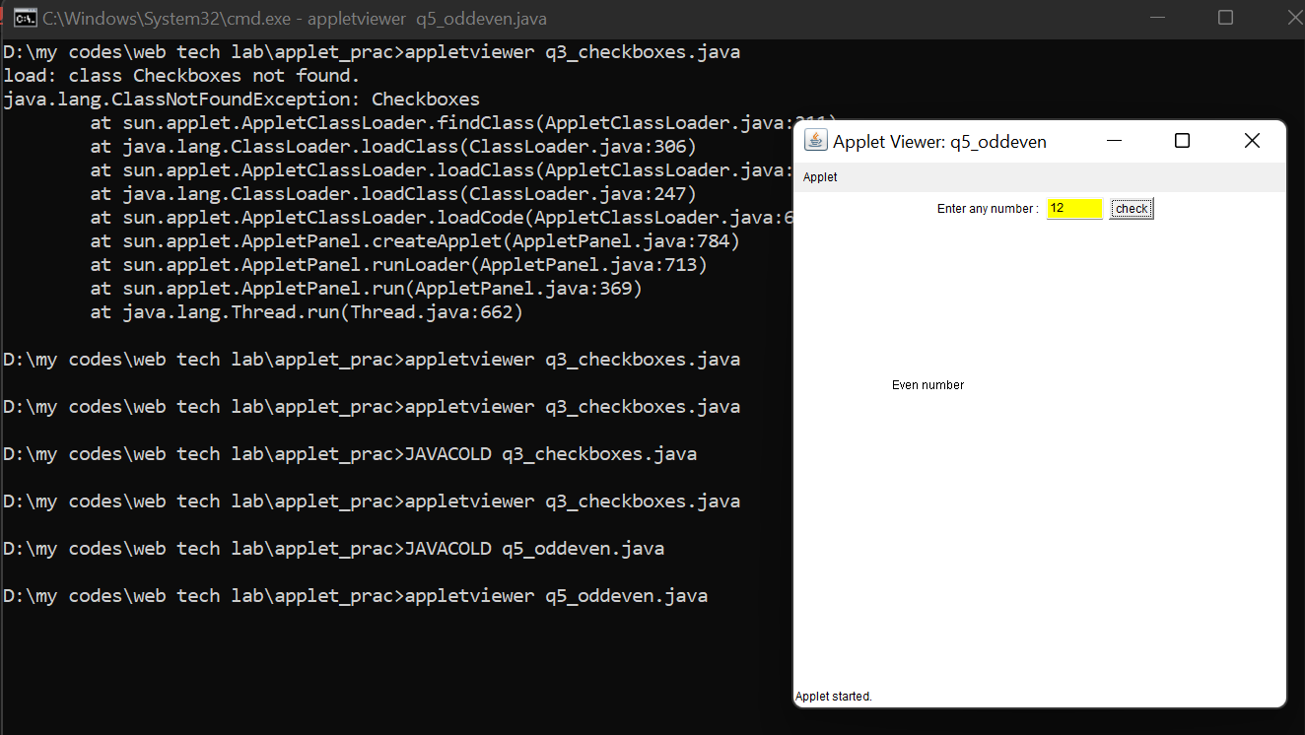

For even no.

For odd no.

